**Solution Q1:**  
**Small Step Sizes (e.g., 0.0001, 0.001, 0.01)**

* **Smooth Descent & Convergence**  
  For small learning rates, the spiral-like function appears to be minimized steadily. The plots show a slow but stable decrease in the objective y, often reaching values near 10−^3 or lower.
* **Longer Time to Converge**  
  The algorithm takes many iterations to get close to the minimum, but it does so without blowing up.

**Medium Step Size (e.g., 0.1)**

* **Mixed Behavior**  
  Some seeds show a partial descent and then the function value skyrockets, while others might converge slowly or in a somewhat erratic pattern.
* **Occasional Divergence**  
  The plots where x1 and x2​ blow up to very large magnitudes and the function value grows extremely large indicate divergence.
* **Sensitivity to Initial Conditions**  
  The difference in behavior across seeds suggests that with λ=0.1, some initial points still allow partial descent, while others cause large jumps and overshooting.

**Large Step Size (e.g., 1.0)**

* **Frequent or Immediate Divergence**  
  Most seeds cause the updates to overshoot drastically. x1 and x2 move rapidly to very large absolute values, and the objective y can jump orders of magnitude upward.
* **Minimal or No Convergence**  
  The few seeds that don’t immediately diverge tend to hover around large values or eventually blow up. You rarely see stable decreases in y.

**Conclusion:**

* **Small λ**: Stable, slow, eventually convergent.
* **Moderate λ**: Can be effective but sometimes diverges, depends heavily on the starting point.
* **Large λ**: High likelihood of divergence—parameters explode to large values, and y becomes huge.

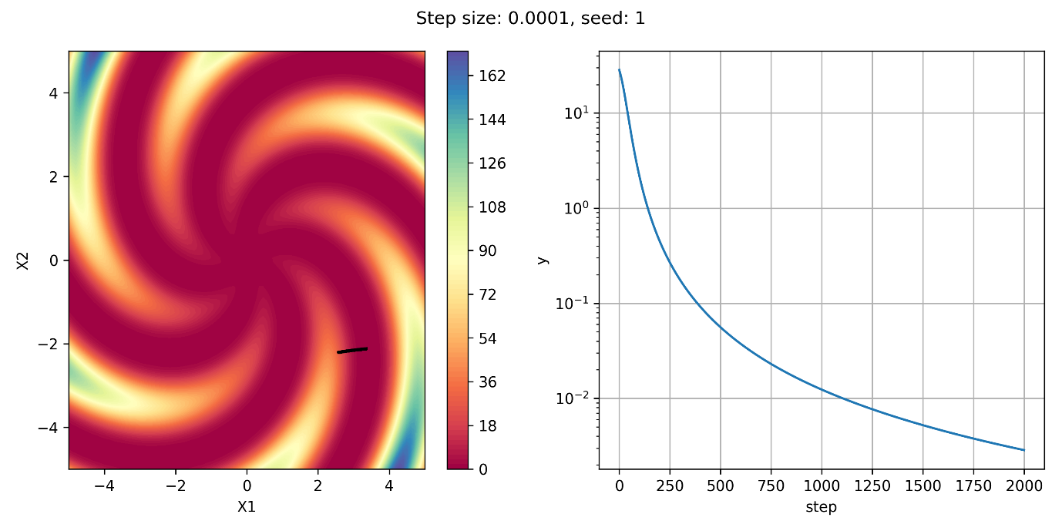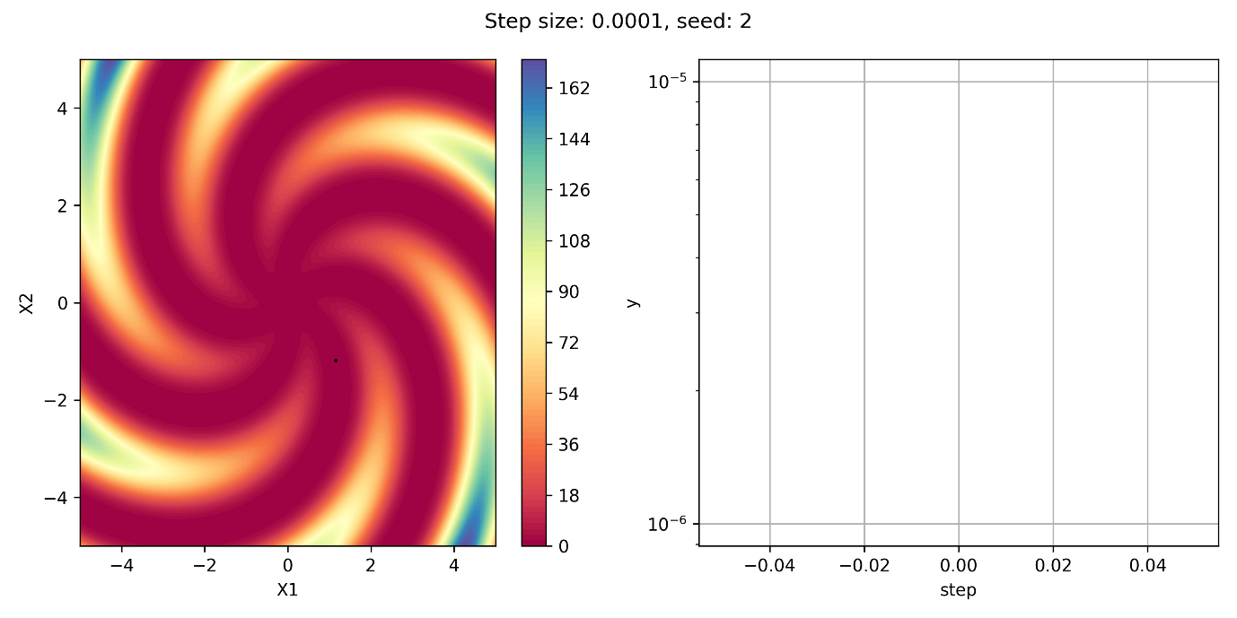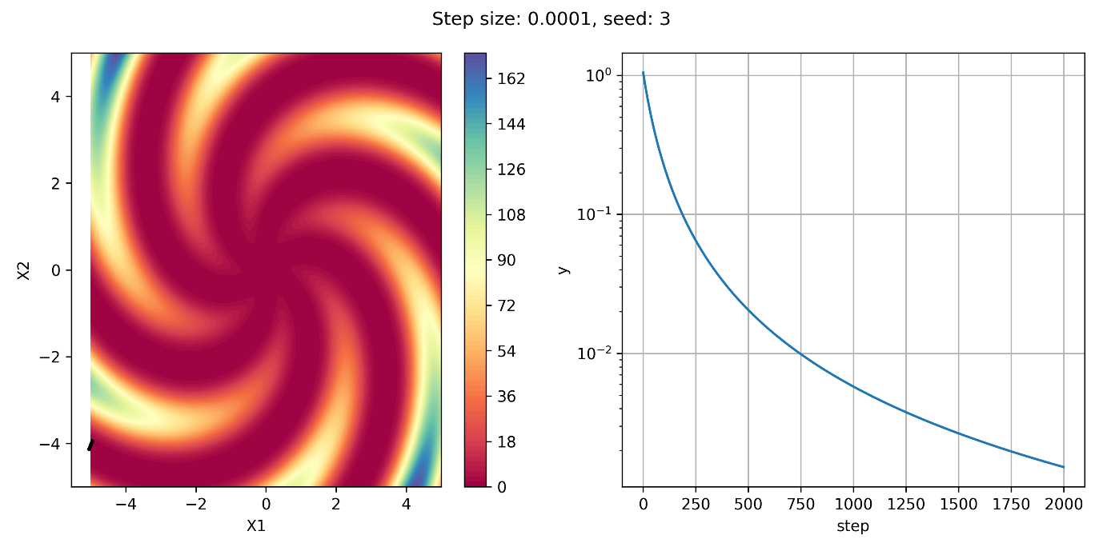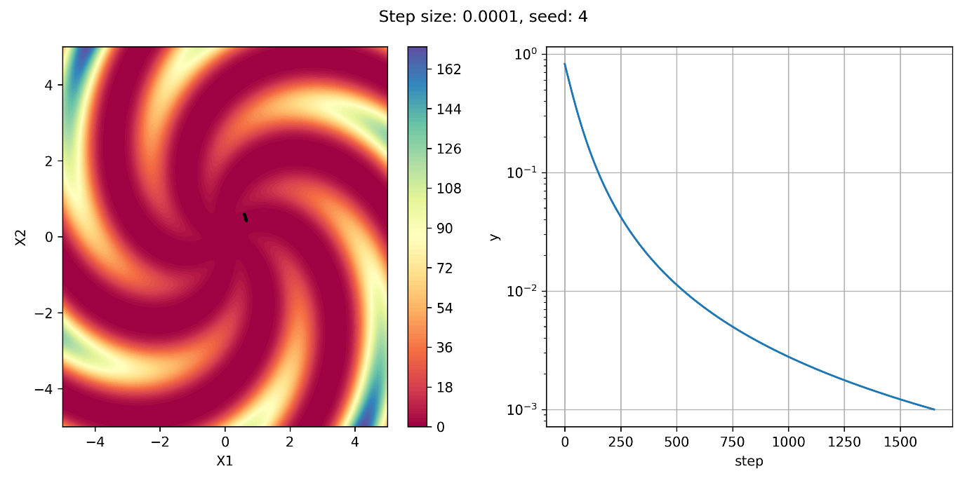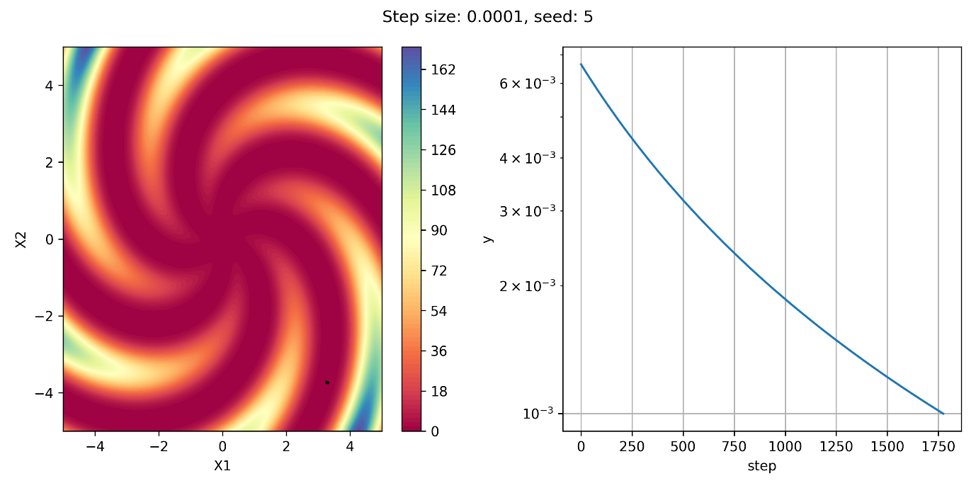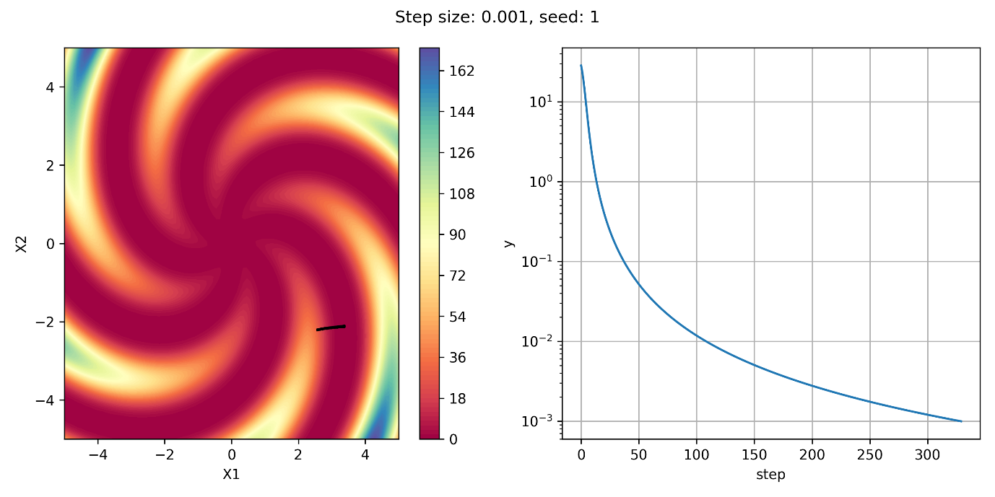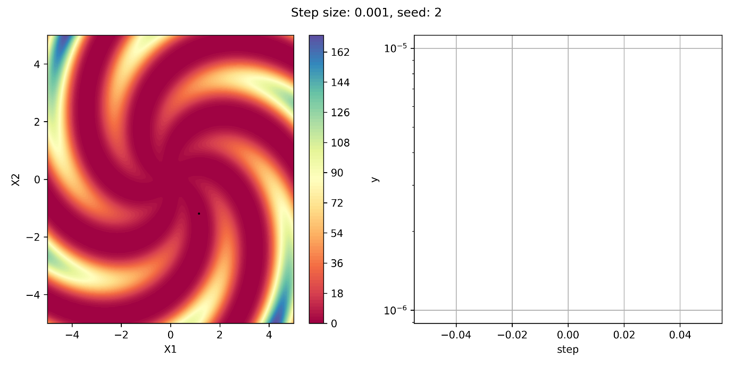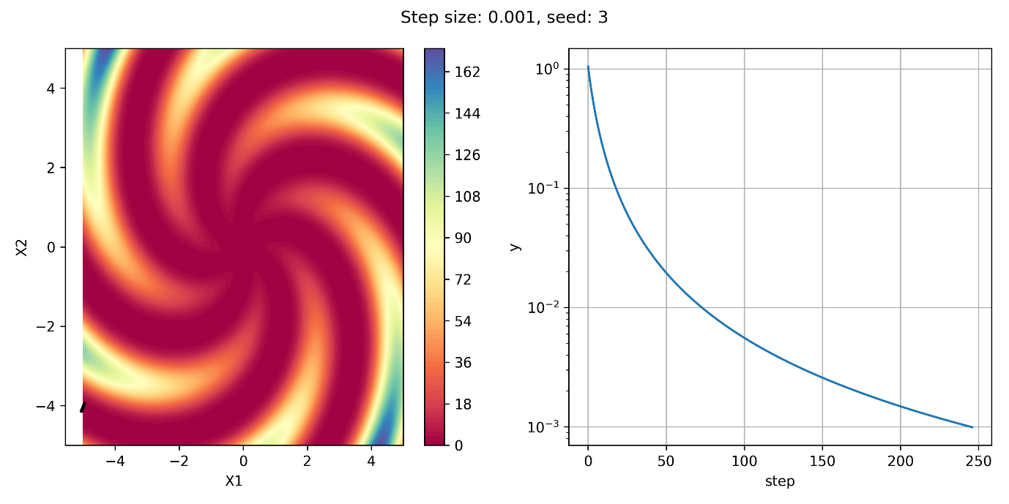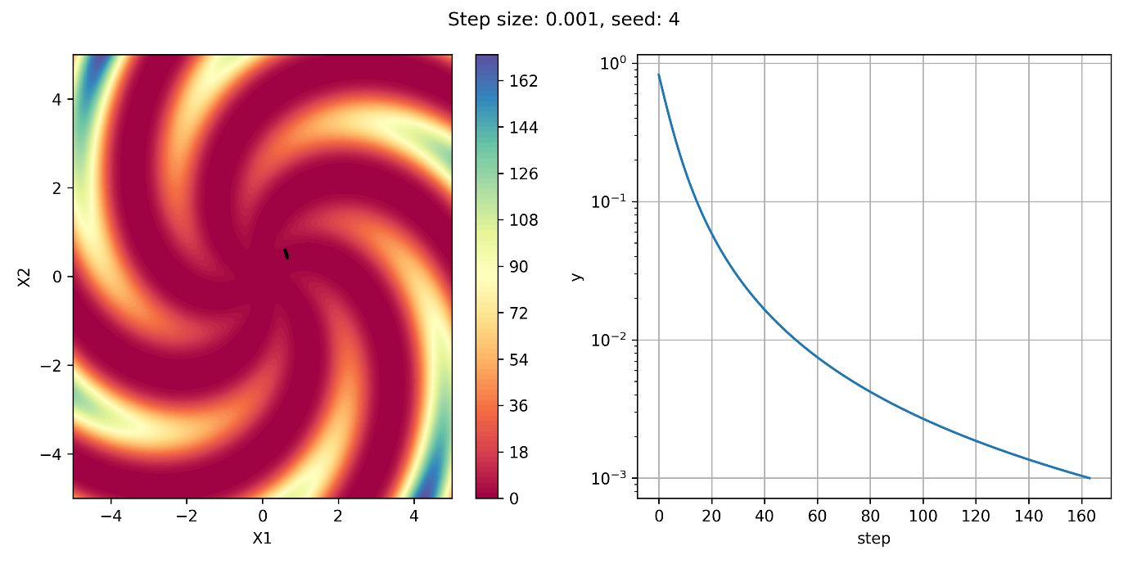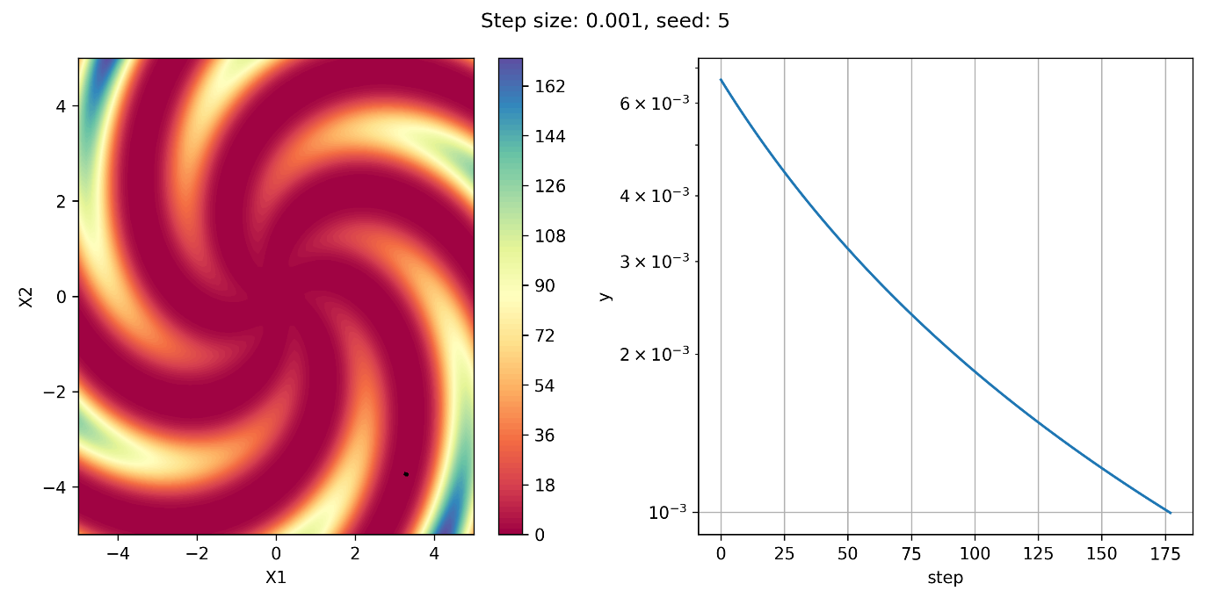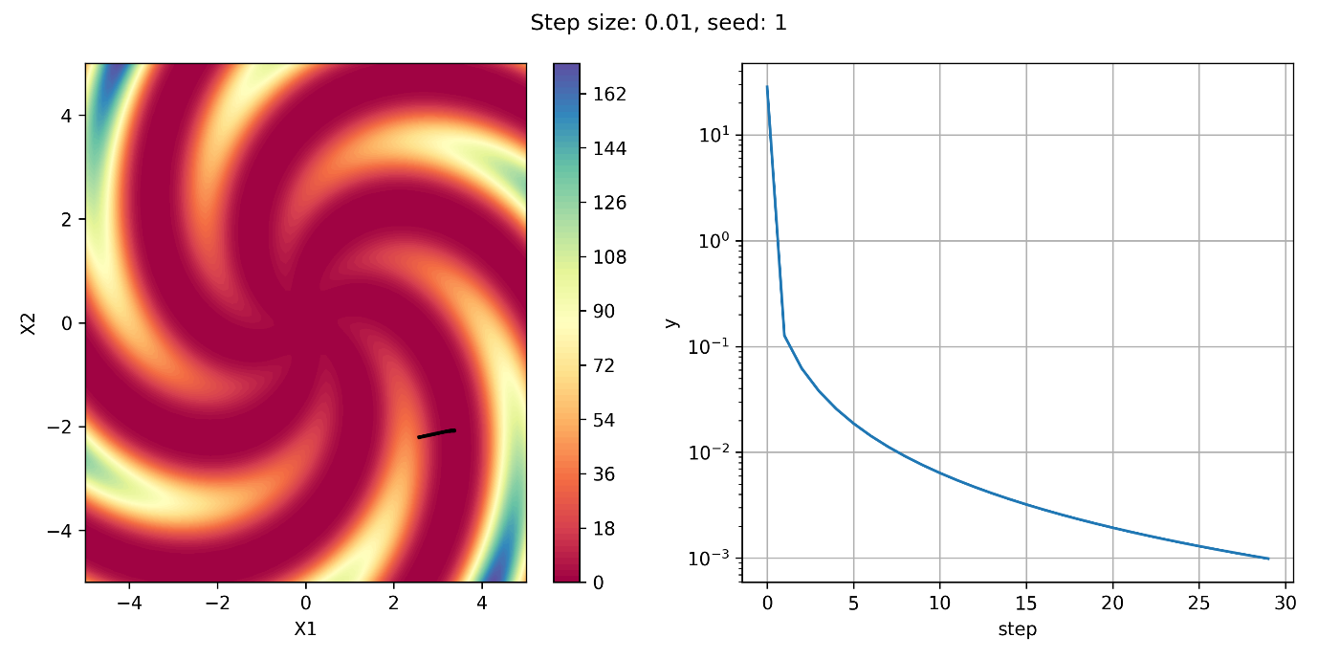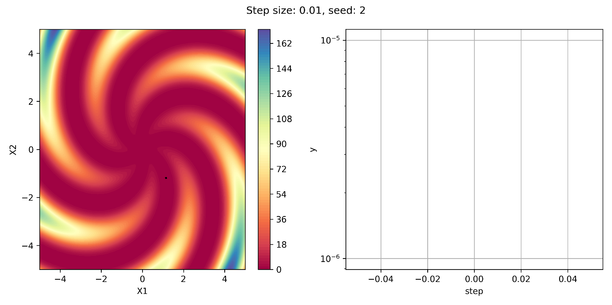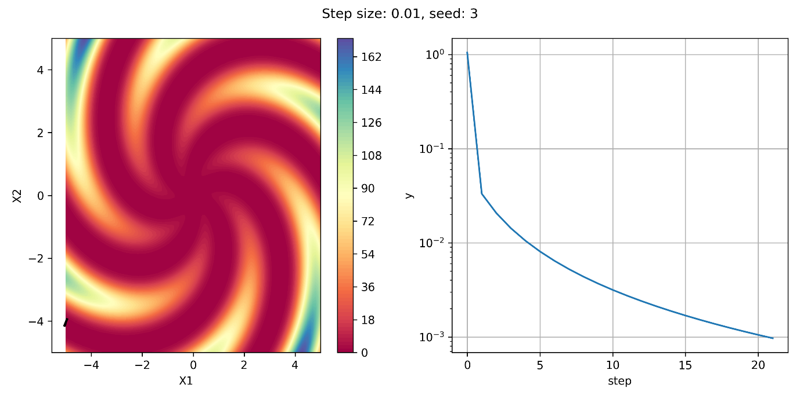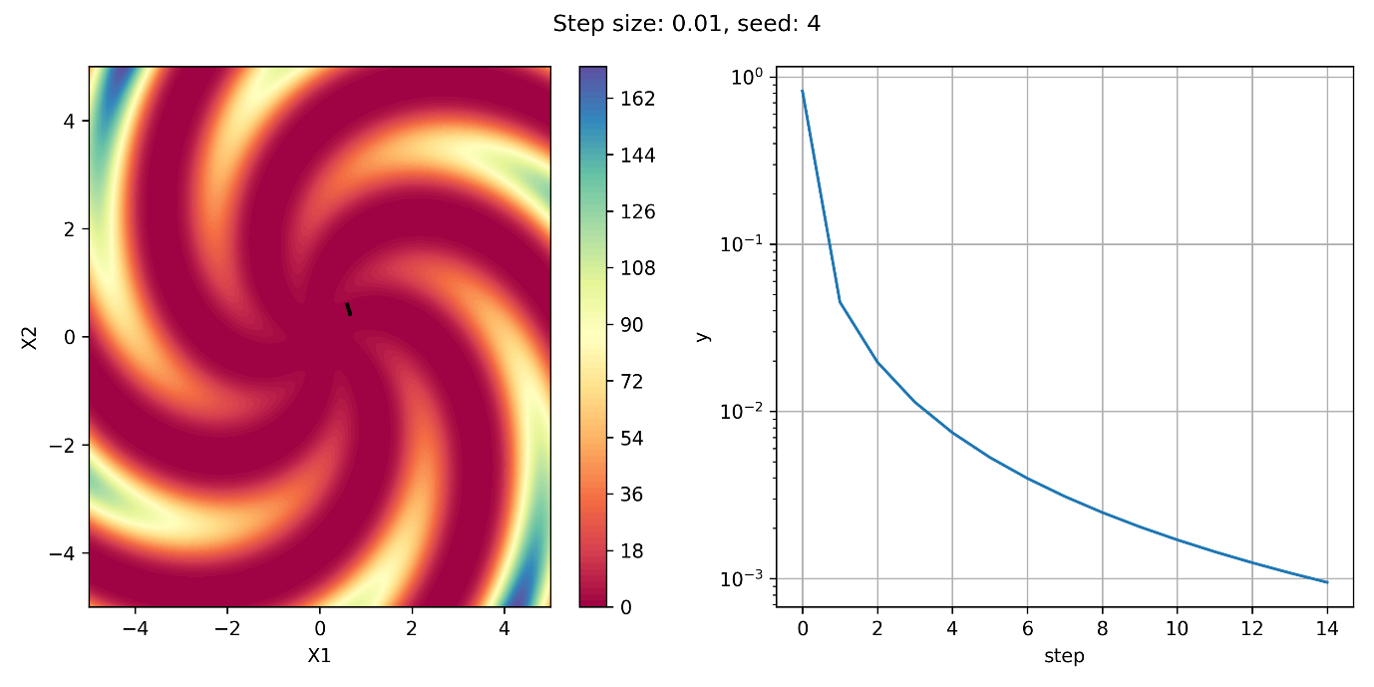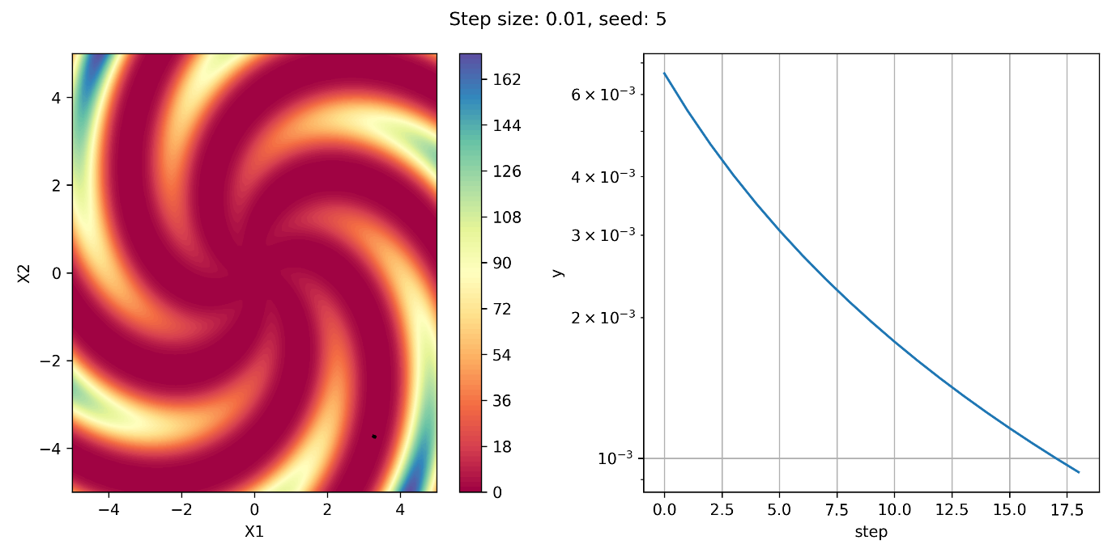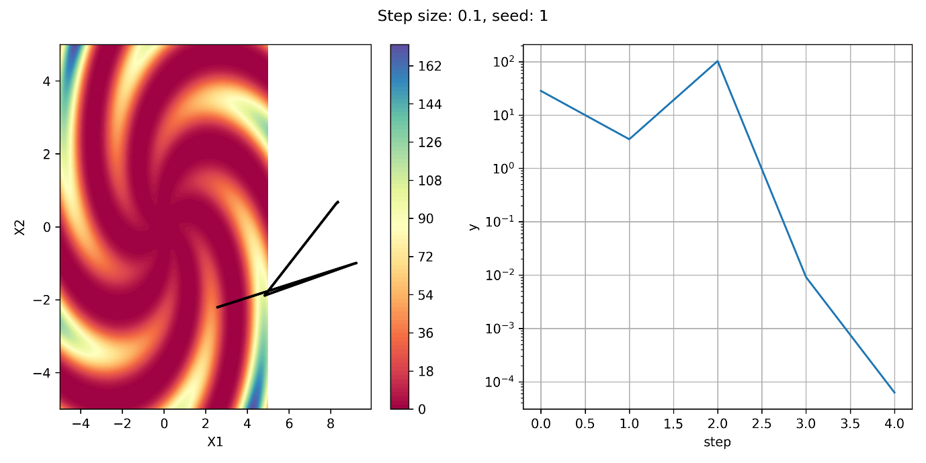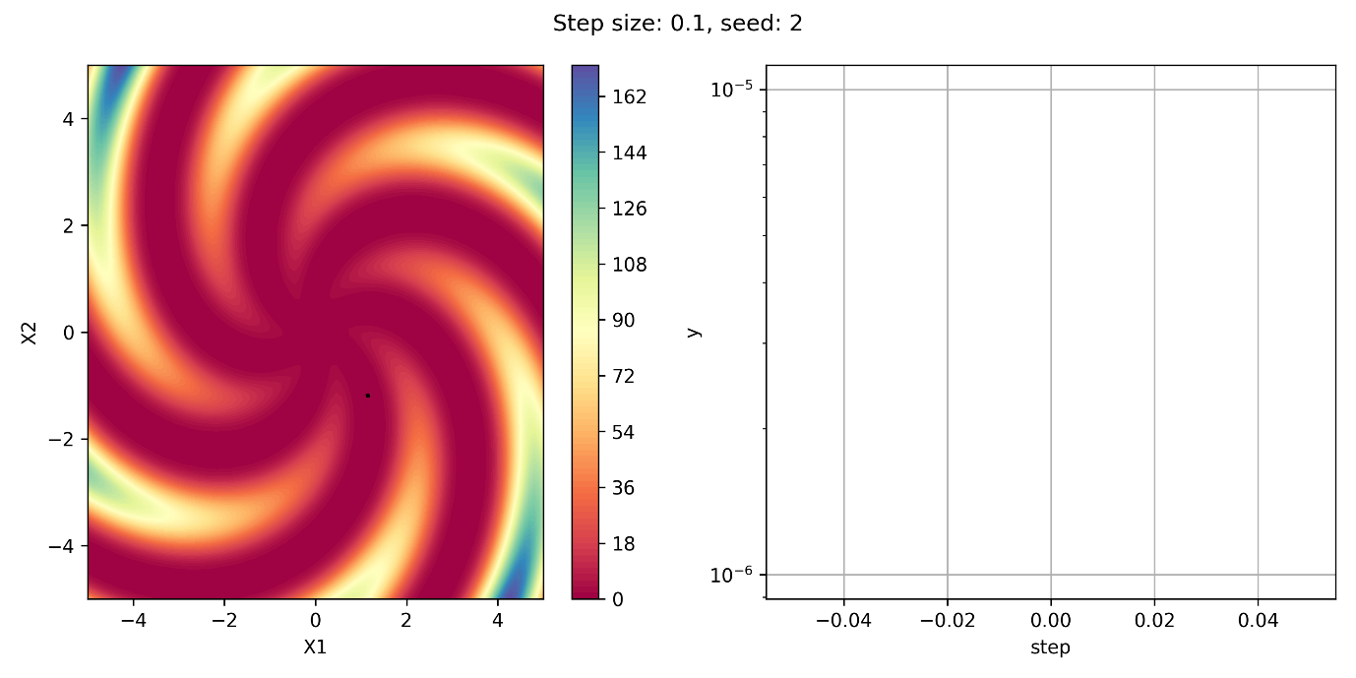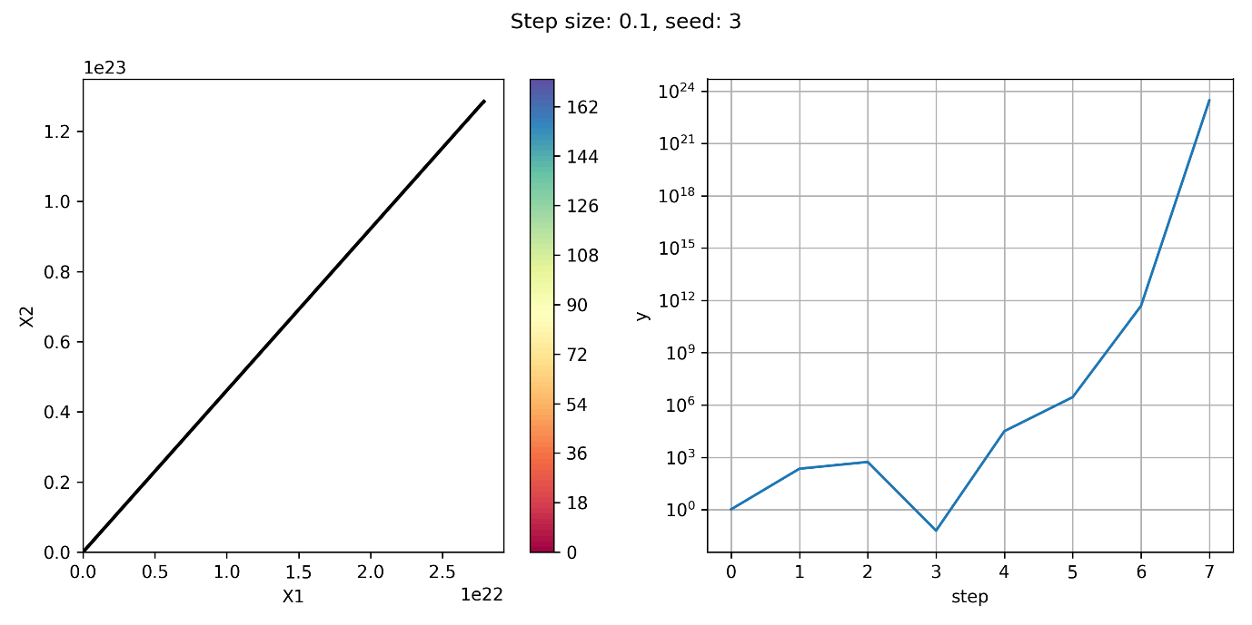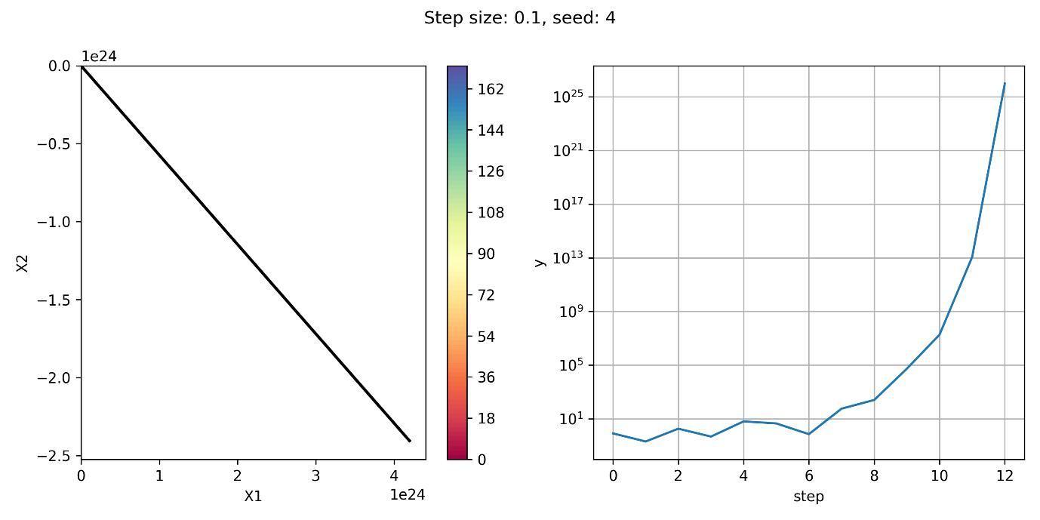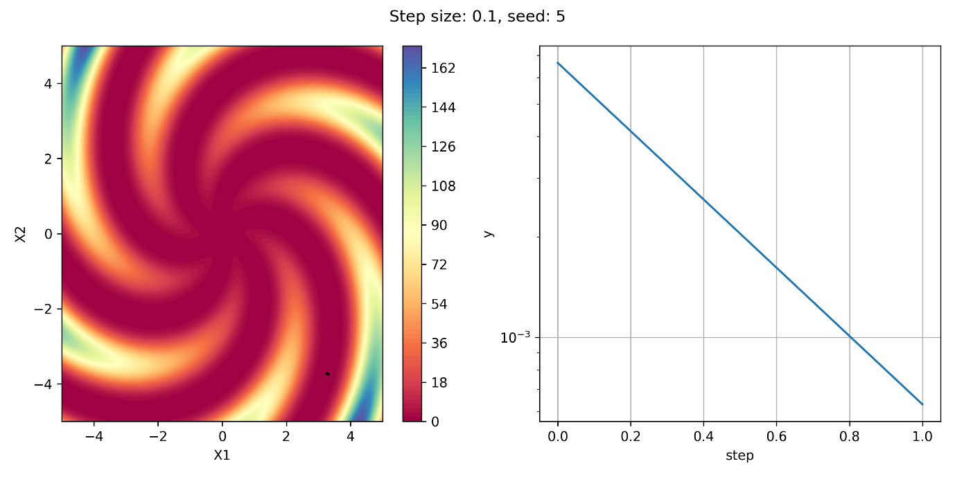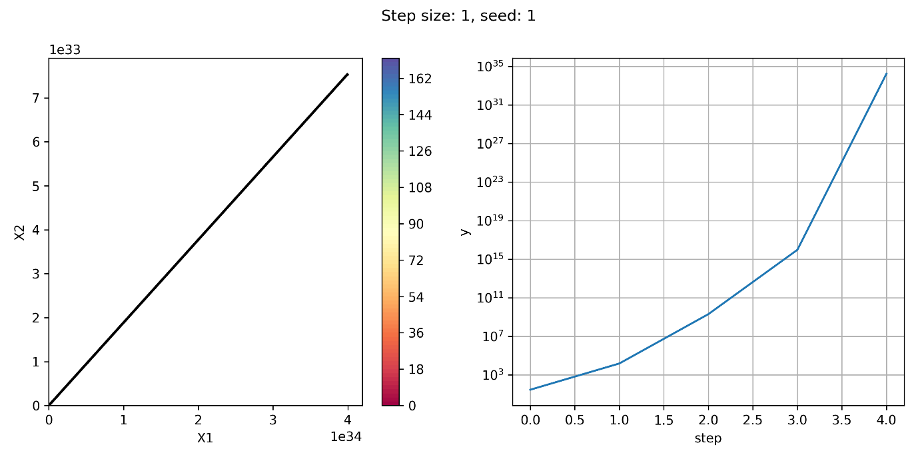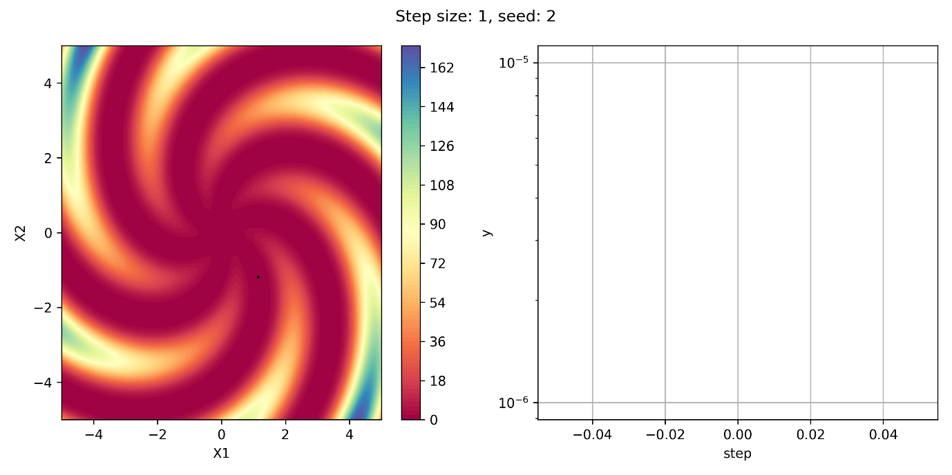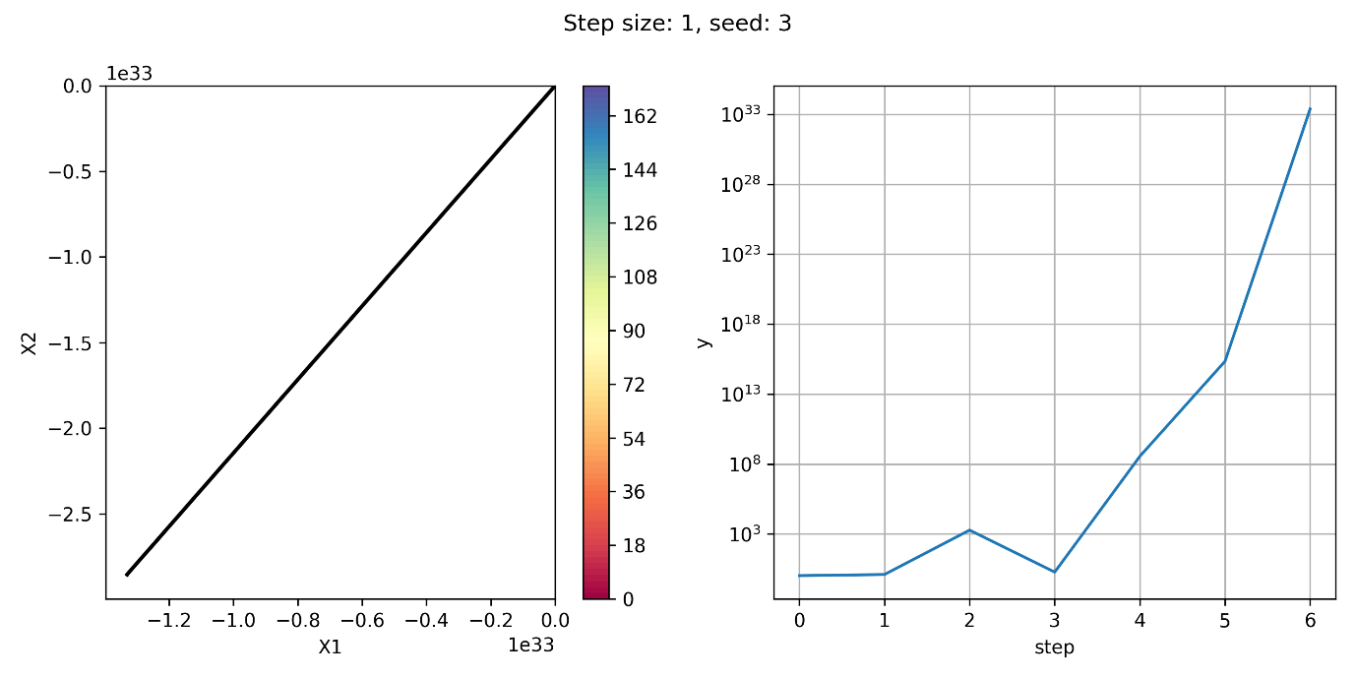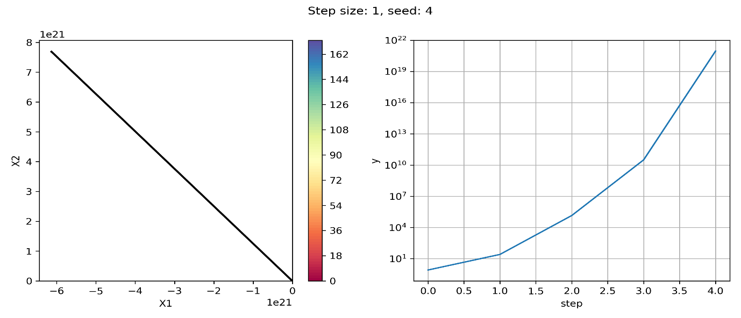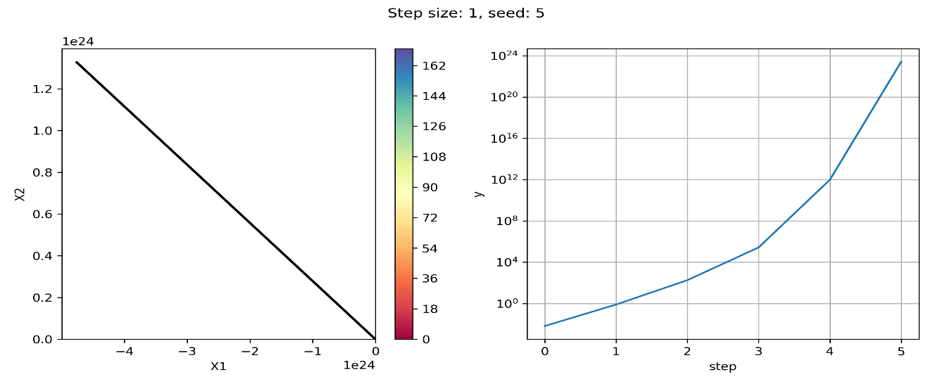

**Solution Q2:**

